# Data tables used for mapping:

# 

Table 1

Table 1 illustrates the datasheet of total number of persons killed in road accidents in Karnataka from 2018 to 2021

# 

Table 2

Table 2 illustrates the datasheet of total number fatal road accidents in Karnataka from 2018 to 2021

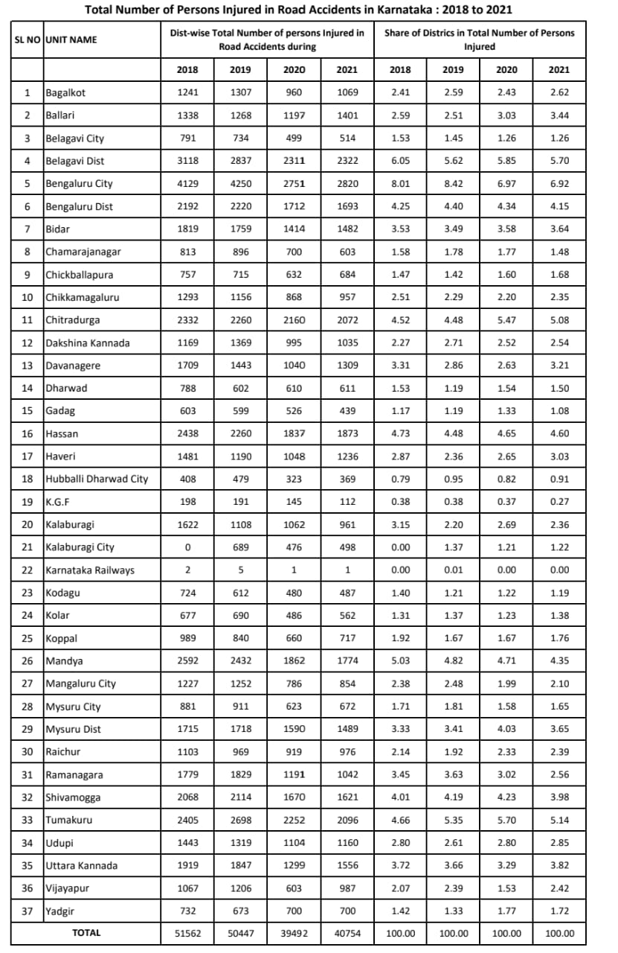

Table 3

Table 3 illustrates the datasheet of total number of persons killed in road accidents in Karnataka from 2018 to 2021

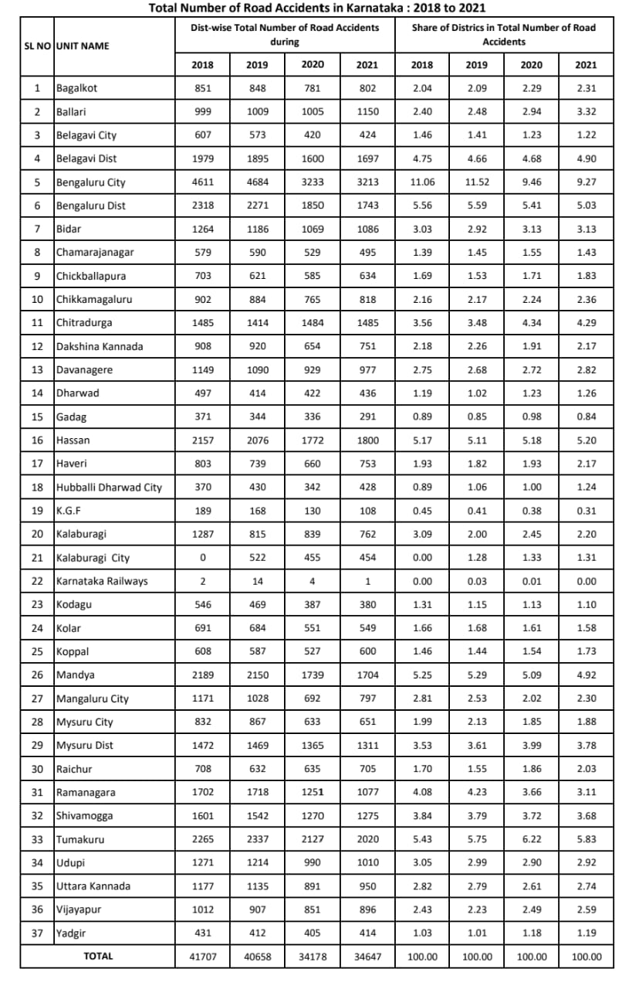

Table 4

Table 4 illustrates the datasheet of total number of road accidents in Karnataka from 2018 to 2021

# Mapping done on QGIS :

Figure 1

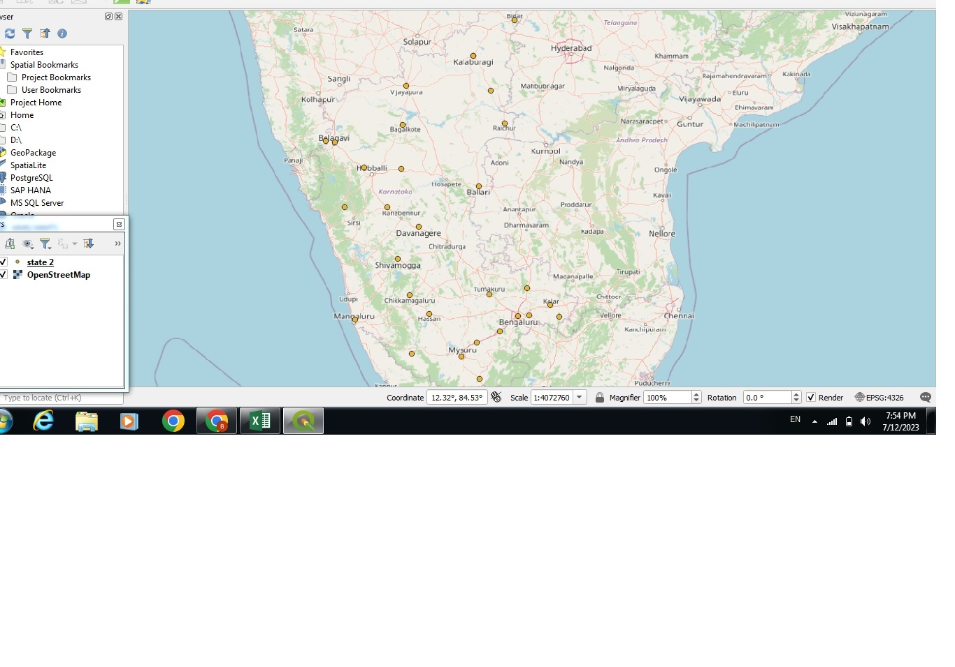

Figure 1 is the visual illustration of the major black spots of Karnataka

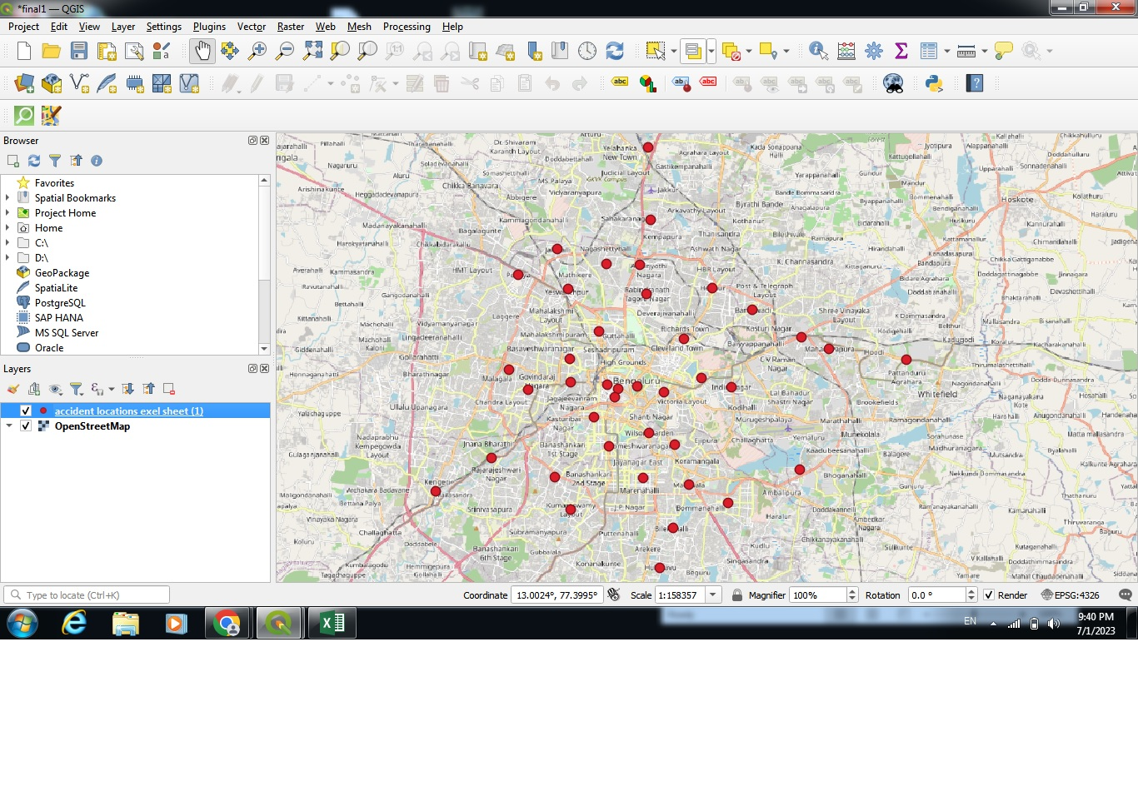

Figure 2

Figure 2 is the visual illustration of the major black spots of Bangalore

# Ways to minimize the accidents

1. Speed control according to black spots
2. Wrong way driving warning
3. Blind spot monitor
4. Surround view system (it'll be useful for curved roads)
5. Driver monitoring system and drowsiness detection
6. Traffic sign recognition
7. Pediatrician warning system
8. Forward collision warning
9. Lane keeping assistance
10. Lane departure warning system

# Technical issue faced:

We were not able to perform the geospatial analysis visualization even after a lot of tries

